Generic Link-Based Answers for Repeat Questions

Some Submitted Questions Are Repeats
Link-based answers kindly point users to the pages that would have answered their question. Link-based answers are not posted online.

Why Do We Need Generic Link-Based Answers?
They keep the site from getting bogged down with the same question, save us time and allow us to focus on improving other aspects of the site. They prevent unnecessary posting work for the webmasters, allow a faster and more complete reply to our users, and encourage our users to look around the site before submitting questions.
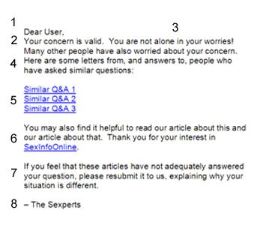
Note the corresponding sections in the general and example pages.

(1) Address the User

(2) Validate their concern
Remember, they are probably very worried. This reassures them that they are getting an answer, not a brush-off.

(3) Transition to the general format

(4) General Address
“Here are some letters from, and answers to, people who have asked similar questions:”

(5)/(6) Link to the similar questions and articles
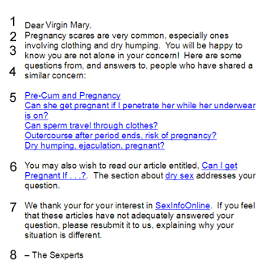
Make sure that the articles are very relevant to their question. Use hyperlinked text on the links. See the section on How to Hyperlink Plain Text. Be very careful that the links are correct or else they will not get their answer! Double-check the links!

(7) General Conclusion
“Thank you for your interest in SexInfoOnline. If you feel that these articles have not adequately answered your question, please resubmit it to us, explaining why your situation is different.”

(8) Sign it

